Solutions Design Specification

FA Rework Inbound Vendor Invoice - Power Platform Solution

Version [1.0]

TABLE OF CONTENTS

TABLE OF CONTENTS 2

1. DOCUMENT CONTROL 3

Version History 3

Validation 3

2. FA Rework for Inbound Vendor Invoice - Power Platform Solution: 4

Business Requirement 4

Process Description 4

Prerequisite 4

Modifications – FA Inbound Vendor Invoice 4

Current Behavior: 4

Proposed Solution: 5

Proof of Concept (POC) Created: 6

POC is created by using following prerequisites. 6

List of connectors used in Power Apps and Power Automate: 6

POC Outcomes: 10

AX data mapping: 12

Test Case: 13

# DOCUMENT CONTROL

## Version History

|  |  |  |  |
| --- | --- | --- | --- |
| *Edition* | *Author* | *Date* | *Details* |
| 1.0 | Almas Gajendragad/Ravi Teja Ragam | 25 Jan 2024 | Reviewed |
| 2.0 | Almas Gajendragad | 29 Feb 2024 | Draft Version |

## Validation

|  |  |  |  |
| --- | --- | --- | --- |
| *Edition* | *Name* | *Date* | *Approval* |
| 1.0 |  | 25 Jan 2024 | Review |
|  |  |  |  |

# FA Rework for Inbound Vendor Invoice - Power Platform Solution:



## Business Requirement

* The details of invoices present in batch job CSV file from AX path should be shown in Power App interface.
* **Shipment status, Invoice Status and pending invoice** status should be visible to user in the app.
* The vendor invoice details should be sent as pdf invoice via mail to finance team.

## Process Description

As part of this modification, we will create a Canvas Application using Power App, in which all the vendor invoice details will be available, also application interface will generate the invoices and send via mail as a pdf document.

## Prerequisite

* An environment should be created in Power App for development purpose.
* Power Platform Premium license is required.
* Batch job file should be available on OneDrive.
* A webservice from AX should be provided with the access.
* A service account should be created.
* Blue VDI
* A gateway setup is required.
* SQL server access should be provided.

## Modifications – FA Inbound Vendor Invoice

### Current Behavior:

Presently in AX there are many other fields in “Inbound vendor Invoice” form which user is not using, also the form consists of lot of data which is making AX system run slower plus the form is updating while posting invoices into CSV file which is impacting the user’s performance.

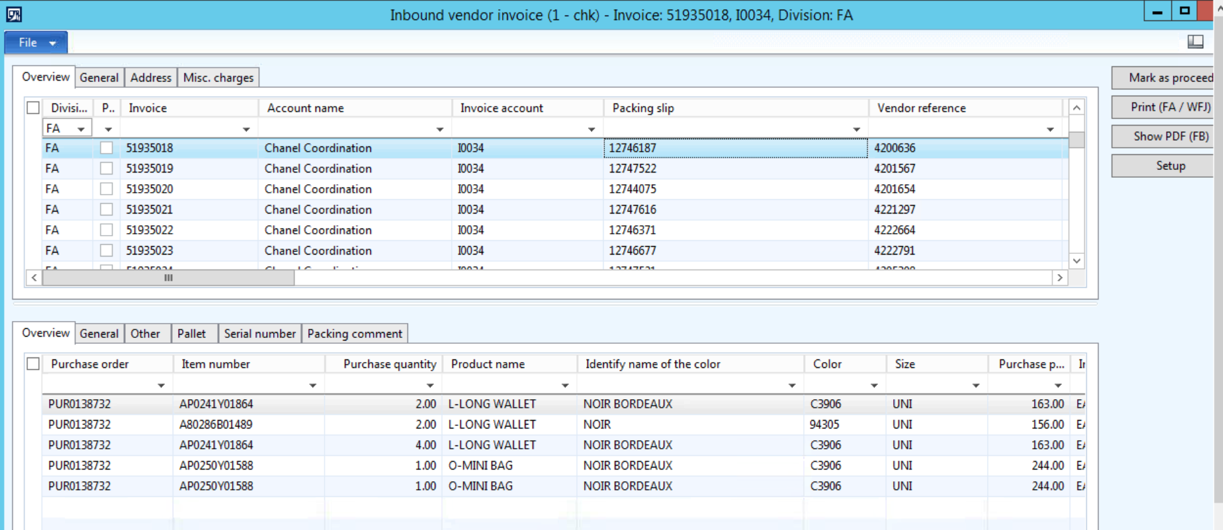

### Proposed Solution:

* Hence, to resolve the issue of AX running slower, RPA team proposed an idea of creating a similar interface as “Inbound vendor Invoice” form outside the AX by creating a Power App application using Power Platform.

**Solution Design:**

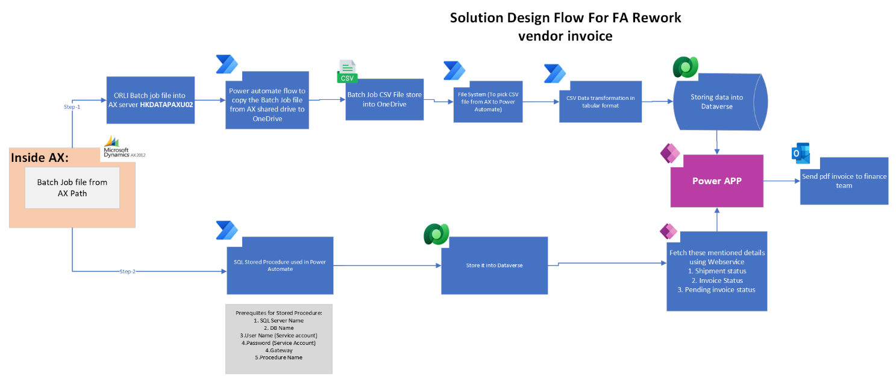

**Entity Representation in Dataverse:**

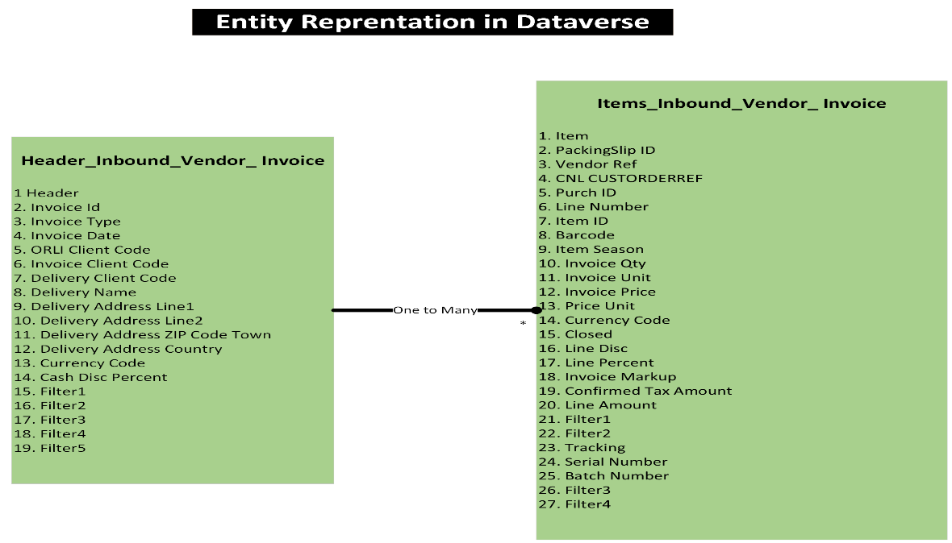

### Proof of Concept (POC) Created:

### POC is created by using following prerequisites.

|  |  |
| --- | --- |
| Service Account | SA-APACFARework |
| Power platform Environment | L_P_APAC_POCFARework_DEV |
| On Premises Data Gateway | SA-APACFARework_DW |
| Batch File path | C:\Users\rravitej\OneDrive-Professional\FA Rework Inbound Vendor Invoice for POC |
| Shared Folder Path for ORLI Batch Job file | \\HKDATAPAXU02\AX_Interface\UAT\CHK\APOLLO\IN\IN |
| AX Server Name | HKDATAPAXU02 |

**List of connectors used in Power Apps and Power Automate:**

1. File System Connector
2. One Drive
3. SQL Server
4. SQL Execute Stored Procedure
5. Excel
6. SharePoint
7. Dataverse
8. Outlook
9. Word Online (Business)
10. Office365 User Group
11. Office365
12. **Component 1: Dataverse**

* The data from CSV file will be transformed and stored into Dataverse tables.

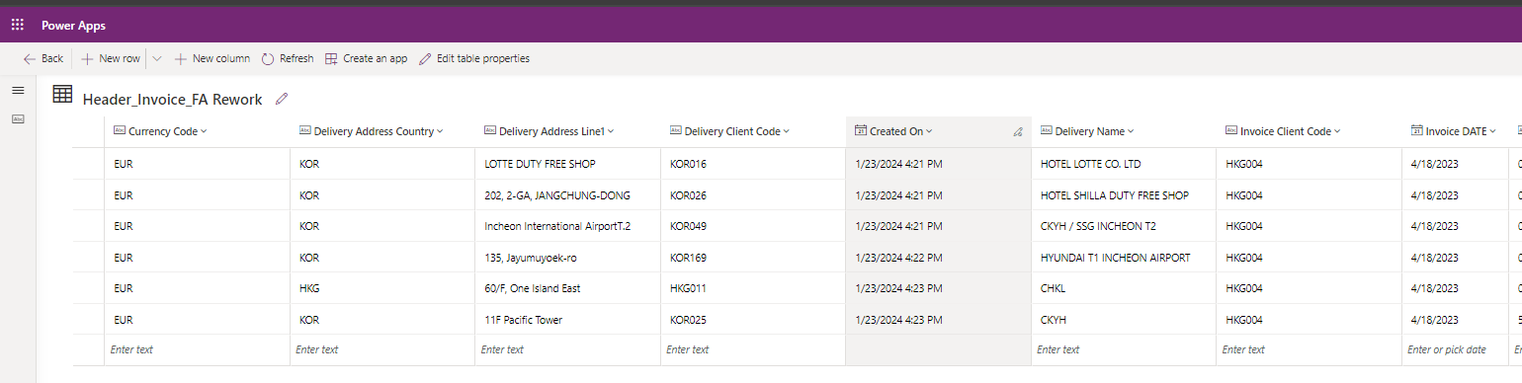

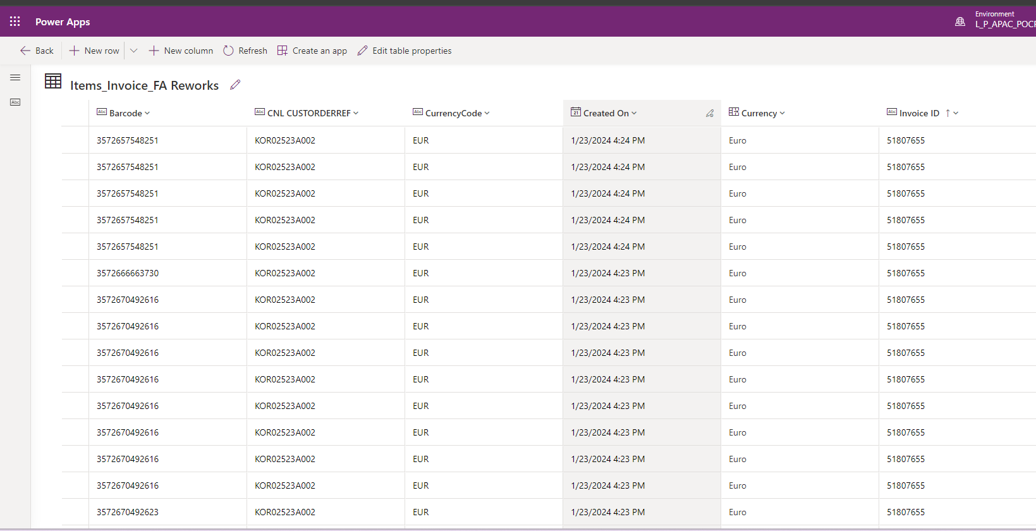

1. **Component 2: OneDrive**

* The batch job file is stored in OneDrive.

**Component 2: Power Automate (1):**

* Power Automate flow is built to transfer the Batch Job file from a shared folder to OneDrive.
* Shared folder path is \\HKDATAPAXU02\AX_Interface\UAT\CHK\APOLLO\IN\IN
* This flow requires a premium connector which is FILE SYSTEM Connector.

1. **Component 3: Power Automate (2):**

* Power Automate is used to pick the Batch job file from OneDrive and transform the csv data into tables and store it into Dataverse.

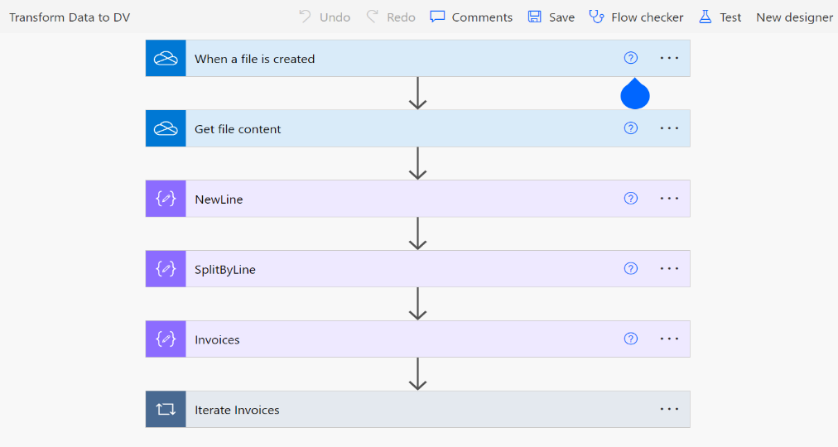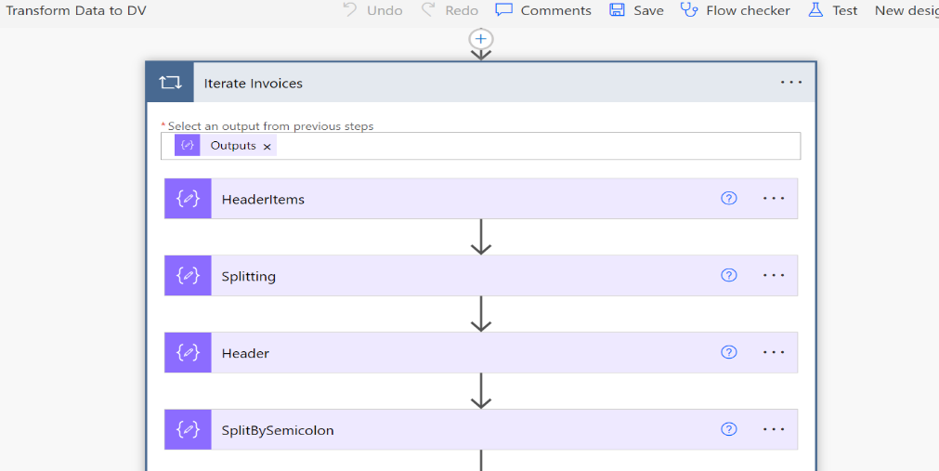

1. **Component 4:** SinceShipment status, Invoice Status and pending invoice status is not available in batch job file and hance we need to fetch these details directly from AX.There are 2methods of fetching Shipment status, Invoice Status and pending invoice from AX.

Refer the below table:

|  |  |  |  |  |
| --- | --- | --- | --- | --- |
| Method | Details | Controller | POC Approach | Approval on Approach |
| Using SQL connector | In Power Apps SQL connector will be used to create the connection for which SQL server access and database admin access is needed.  The following are the SQL tables from which the data needs to be fetched.   * VendInvoiceJour - InvoiceId * VendPackingSlipJour - cnlASShipmentNumber * VendInvoiceInfoTable -. Num(InvoiceId) | On premise data Gateway, Access to SQL server and Database. | **Checkmark with solid fill**Yes  (This Approach has been followed for POC creation) | Review |
| OAuth 2.0 | Required following details to configure custom connection in Power apps.   * Client ID * Client Secret * Authorization URL * Token URL * Refresh URL * Scope * Redirect URL | Azure APIM | No | Review |

1. **Using SQL Connector:**

* Using SQL connector is one of the ways to fetch the tables from SQL by using on premises data gateway also requires access to SQL server and Database.

1. **Using OAuth 2.0:**

* Using OAuth2.0 authentication method is another way which require an API followed with HTTPS protocols.
* 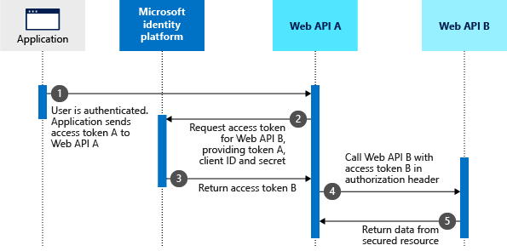OAuth2.0 Authentication should be used to consume the webservice from AX via Azure APIM.
* A custom connector needs to be created in Power App to fetch Shipment status, Invoice Status and pending invoice status using webservice from AX.

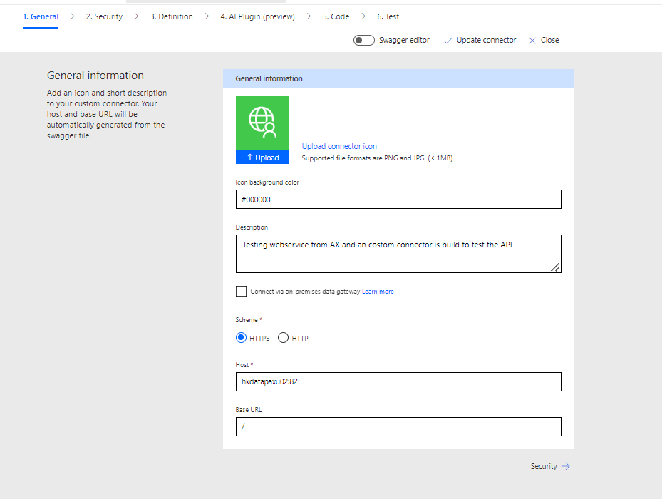

1. **Component 5:** Power Apps: Microsoft Power App is required for building application interface.
2. **Component 6: Service account:**

* A service account is required for Application building process and creation of custom connector and overall management.

1. **Component 7: Blue VDI:**

* Require having a Blue VDI on which the process can run unattended.

1. **Component 8: One Premises Data gateway:**

* Require having a data gateway for the connection with local host APIs or directly to SQL server for future dependencies.

**POC Outcomes:**

1. **Application Interface:** POC will be build using Power Apps.

* Power App application will be created which will have similar interface as AX.
* 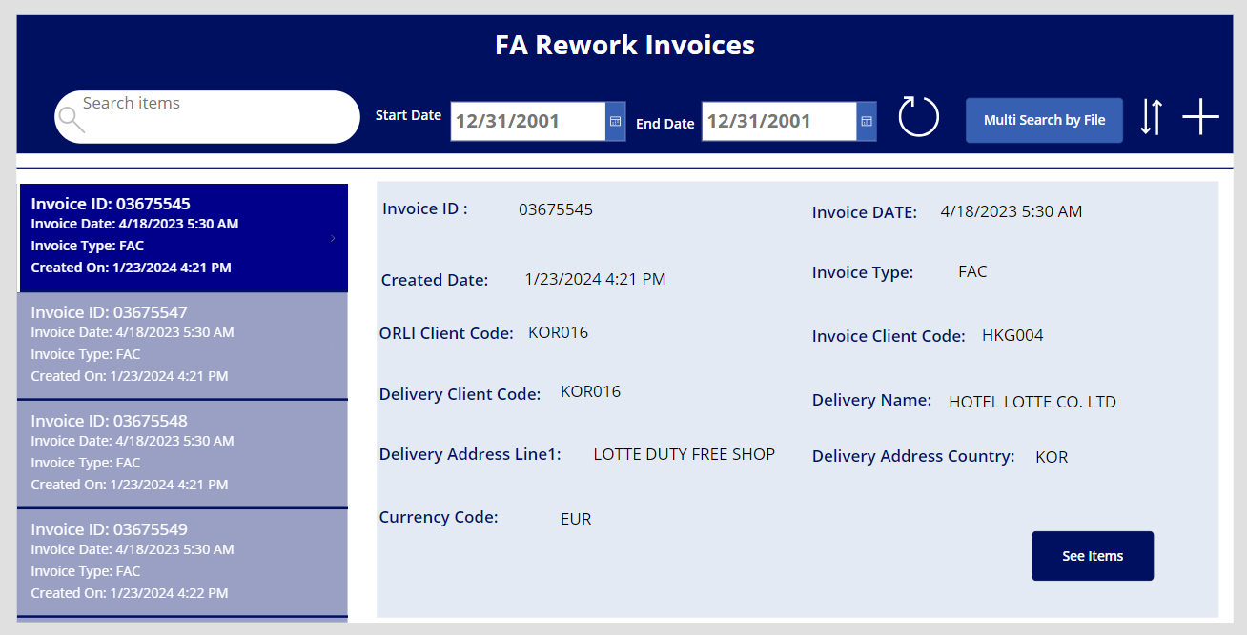**Home Screen:**
* 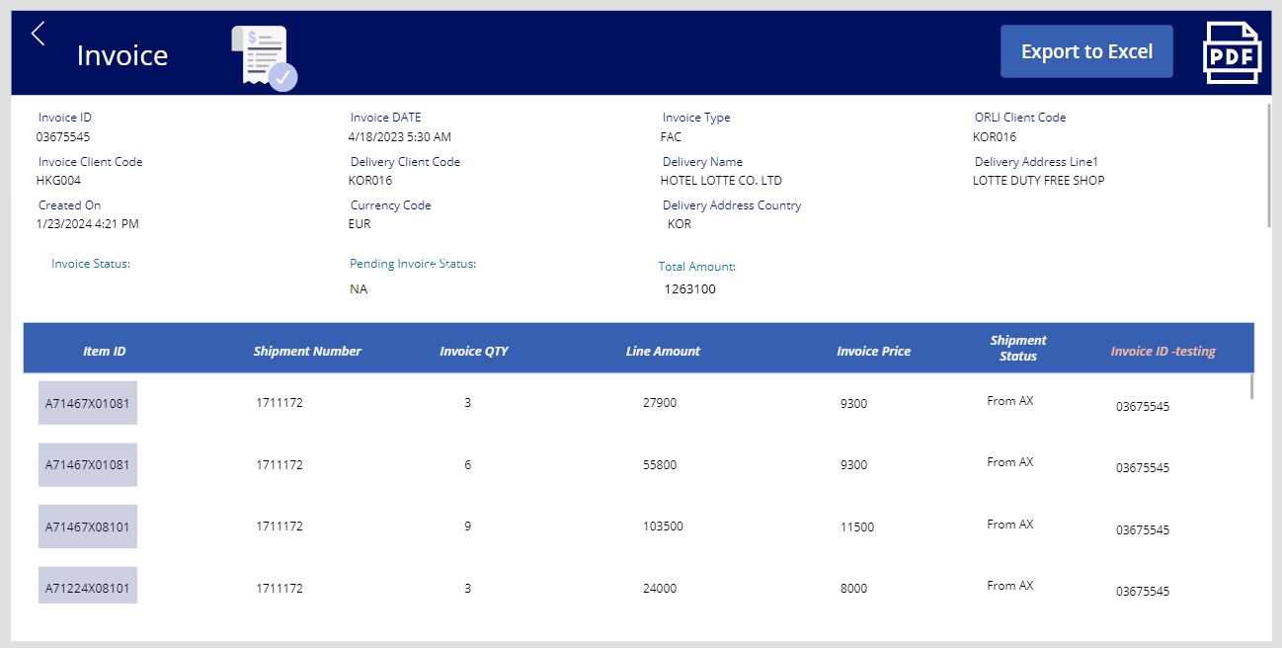**Details Screen:**

1. **Pdf Generation from Power App:**

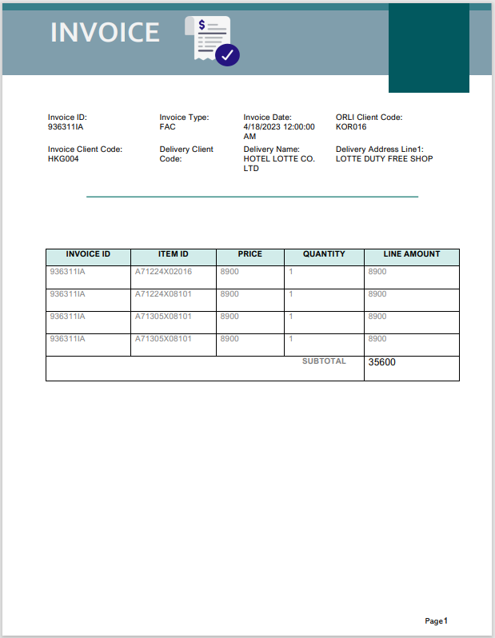

1. **Generating Excel from Power App:**

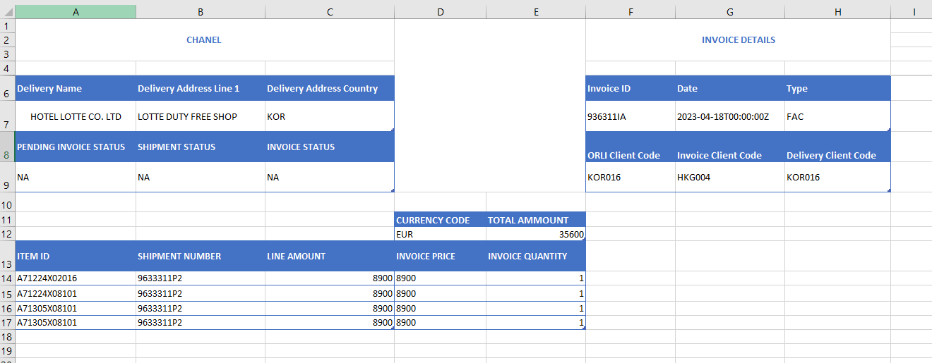

**AX data mapping:**

**Please find below the mapping:**

|  |  |  |
| --- | --- | --- |
| ***Mapper Type*** | ***Mapper Name*** | ***Mapped Id*** |
| Header | HEADER | * Invoice Id * Invoice Type * Invoice Date * ORLI Client Code * Invoice Client Code * Delivery Client Code * Delivery Name * Delivery Address Line1 * Delivery Address Line2 * Delivery Address ZIP Code Town * Delivery Address Country * Currency Code * Cash Disc Percent * Filter1 * Filter2 * Filter3 * Filter4 * Filter5 |
| Line | ITEM | * PackingSlip ID * Vendor Ref * CNL CUSTORDERREF * Purch ID * Line Number * Item ID * Barcode * Item Season * Invoice Qty * Invoice Unit * Invoice Price * Price Unit * Currency Code * Closed * Line Disc * Line Percent * Invoice Markup * Confirmed Tax Amount * Line Amount * Filter1 * Filter2 |
| Line | TRACKING | * Serial Number * Batch Number * Filter3 * Filter4 |

* Below fields details will be extracted from AX since these details are not available in batch job file.
* Shipment Status
* Pending Invoice Status
* Invoiced Status

|  |  |
| --- | --- |
| Fields | Logic to update the fields |
| Shipment Status | A custom connector will be used to fetch the Shipment status directly from AX |
| Pending Invoice Status | A custom connector will be used to fetch the Pending Invoice Status directly from AX |
| Invoice Status | A custom connector will be used to fetch the Invoice Status directly from AX |

### Test Case:

1. Validate the data in Power App.
2. Multi search available i.e., at a time user can check for multiple Invoices in search bar.
3. Filter the data based in Date range available.
4. “See Items” button will take the user to a new screen with the item details for respective Invoice ID.
5. “PDF” button will generate a pdf document for Invoice ID which is currently shown in app interface and send it on outlook.
6. “Export to Excel” button exports the selected data into excel format and send the same on outlook.